Meets: Tuesdays 09.40-13.30, Wednesday 10:40-12:30 and Fridays 10:40-13:30.
Instructors: Instructor Ziya TANALI, Assist. Prof. Dr. Z. Ezgi KAHRAMAN, Assist. Prof. Dr. Özgül Burcu ÖZDEMİR SARI, Instructor Dr. Deniz ALTAY KAYA, Instr. Dr. Olgu Sümengen Berker, Instr. Elif Tolun, Res. Asst. Semih KELLECİ. _________________________________________________________________________________

Supply for the next studio time:
- Model making equipments (cardboard/model board, glue, scissors, utility knife etc.).
Homework:
- Until the next class (Oct., 22, 2013), you will develop your project and submit your results in the class.
Next Class:
- Next class (Oct., 22, 2013), you will work in the class and you will put your projects on display at 12.30 am.

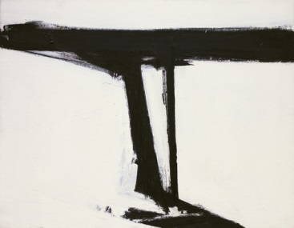

ASSIGNMENT III 04.Oct.2013
“Little yet Much”

Problem:
You are asked to express the sensitivity of “little yet much” by using a cube with the dimensions of 30×30×30 cm.
You are free to use any materials you like to build your cube and use any method/material you like to express the sensitivity of “little yet much”; however you are expected to think about the visual and formal character of your final product and attain a unity within it.

Final Due: Nov.,01, 2013

